**Introduction**

As its name indicates, the Glossary is a collection of terms with their definitions related to a topic. The teacher can set up the Glossary activity, and the students can contribute entries to it. It is possible to attach files and display images with glossary terms. The Glossary can be searched or browsed alphabetically or by Category, date, or Author. There is a provision for making comments on entries and rating them.

**Setting Up of Glossary Activity**

The following are the steps to set up a choice activity in a course.

1. Select the **Turn Editing On** button from the **gear** icon at the top right corner
2. Click the **Add an activity or resource** link and select **Glossary** from the Activity Chooser
3. Add a **name** and **description** for the Choice and decide whether the description should be **display**ed **on the course page**
4. Glossary Type: There are two types of glossary entries Main and Secondary. There can be only one main Glossary and multiple secondary glossaries for a course. By default, the *Secondary Glossary will be selected*.
5. Under **Entries**:
6. If **Approved by default** is set as NO, an entry made by a student to the Glossary will need the teacher's approval to be viewed by others.
7. If **Always allow editing** option is set as **YES**, the student can edit his entry at any time. Otherwise, it will be permitted only within 30 minutes of entering the entry.
8. If the **Duplicate entries allowed** option is set as **YES**, the same concept can be entered by the students multiple times
9. The **Allow comments on entries** is for permitting the glossary users to make comments on entries
10. **Automatically link glossary entries** option facilitates linking the glossary terms appearing at other parts of the course.
11. Under **Appearance** decide:
12. **Display format** and **Approval display format** of the Glossary entries from among the seven options: (1) *Simple*, *dictionary style*, (2) *Continuous without Author*, (3) *Full with Author*, (4) *Full without Author*, (5) *Encyclopedia*, (6) *Entry list* and (7) *FAQ*
13. **Entries shown per page**
14. Whether to **Show alphabet links** or not
15. Whether to **Show 'ALL' link** or not (*ALL link permits the users to browse all the entries at once)*
16. Whether to **Show 'Special' link** or not (*Special link permits Glossary browsing by special characters such as @ and #*)
17. Whether to **Allow print view** or not
18. Maintain the default settings for **Ratings**, **Common module**, **Restrict access**, **Activity completion**, **Tags,** and **Competencies.**
19. Click the **Save and Display** button.
20. In the resulting window (Figure ), click **Browse by category** button🡪**Add Category**
21. Here, add as many numbers of categories required for the Glossary. E.g., Topics discussed in each unit can have a glossary. Thus, Add *Unit1, Unit2, Unit3,* and*Unit4* as categories. Also, click **Automatically link this Category** while adding each Category.

Note: *Categories cannot be created for Simple*, *dictionary style display format*

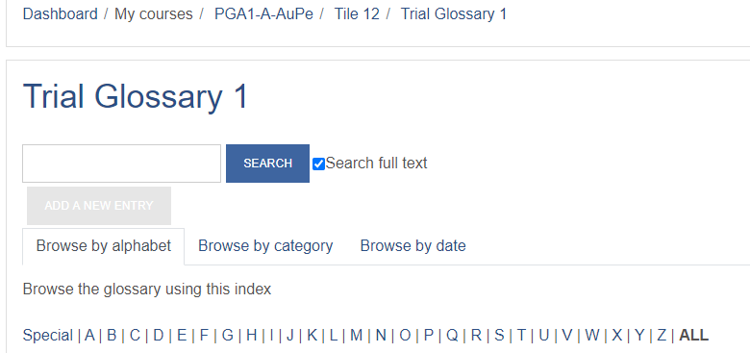

1. Click the BACK button after creating the categories (Figure )

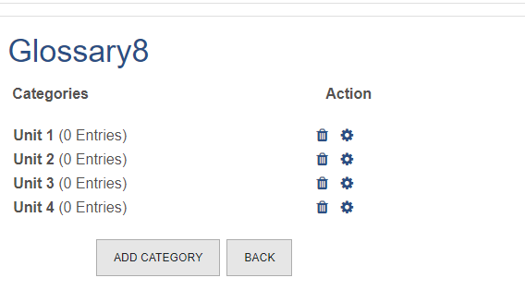

1. Now, click the ADD A NEW ENTRYbutton (*appeared in grey*). (Figure )
2. In the C**oncept** box, enter the glossary term and describe it in the **Definition** text editor.
3. Then select the **Category**, followed by **Keywords (synonyms)**, if any
4. Attach **file**, if any.
5. Under **Auto-linking**, make necessary changes, if required (‘*This entry should be automatically linked’, ‘This entry is case sensitive’, ‘Match whole words only’*)
6. Enter **Tags,** if any
7. Click the **SAVE CHANGES** button
8. Repeat **steps 12 to 18** for entering all the glossary terms
9. Now, the Glossary can be browsed by Alphabet, Category,Date of Creation and Author (*full with author*)